Gramene Ontology Module Exercises
Gene Ontology
Go to http://www.gramene.org and select “Ontology” from the navigation bar.
1a. Search for the term “polysaccharide biosynthesis” and report its GO id and its definition.

1) Enter “polysaccharide biosynthesis” in the Ontology Search field, as shown below.

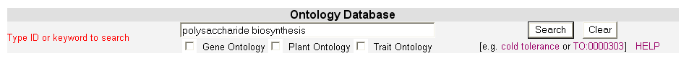

2) The following Summary page will result.

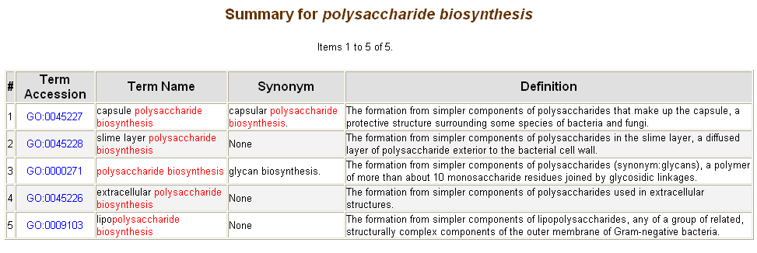
Answer: The GO id is GO:0000271 and its definition is “The formation from simpler components of polysaccharides (synonym:glycans), a polymer of more than about 10 monosaccharide residues joined by glycosidic linkages.”

1b. How many of its children have children of their own?

Select the appropriate Term accession, as shown above. The following Summary Page will result. The symbol indicates that the tree is expandable, i.e., the children terms have children terms of their own.

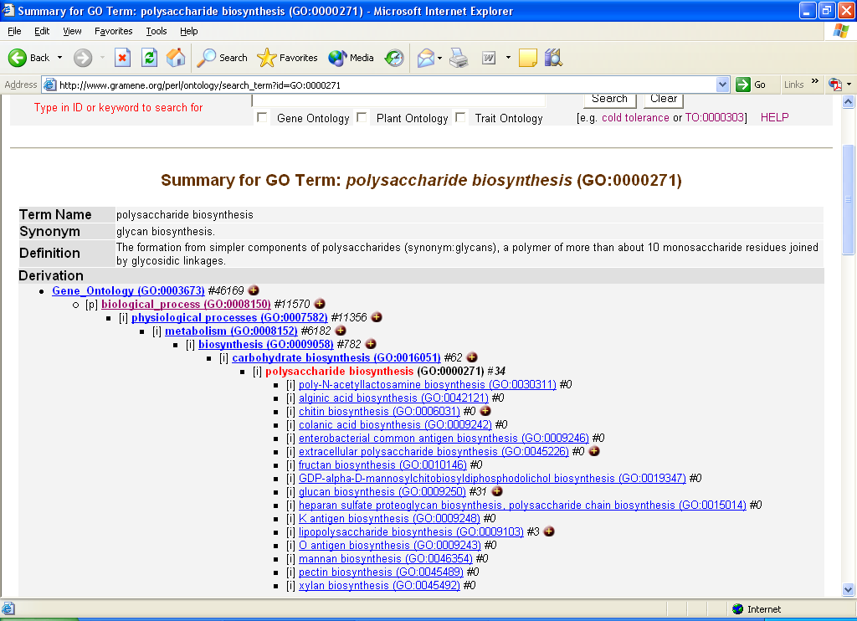

Answer: Four children terms also have children of their own.

1c. How many total (direct and indirect) number of proteins are associated to the GO term polysaccharide biosynthesis? Are there any proteins which are not directly associated to this term? If so, which child term has the greatest number of associations?

1) In the same Summary page, examine the number next to the term “polysaccharide biosynthesis.” That number indicates the total number of proteins associated. Then examine the number next to the children terms. Adding them together indicates the number of proteins not directly associated to the term, as shown below.

2) To find the child term with the greatest number of associations, examine the Gene Product Association list, as shown below.

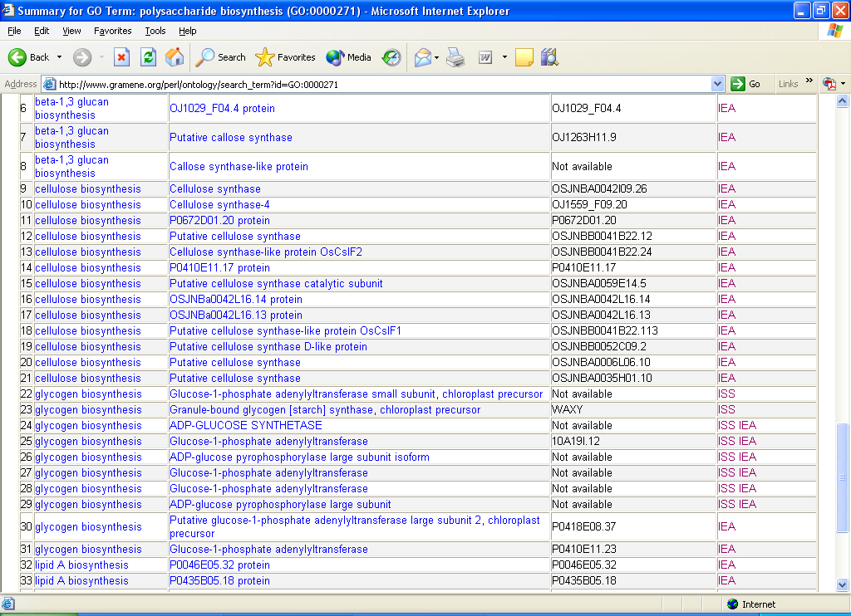

Answer: There are 34 proteins associated to the term 'polysaccharide biosynthesis'. There are 34 proteins not directly associated to the term 'polysaccharide biosynthesis'. “Cellulose biosynthesis” has the greatest number (13) of associated proteins.

1d. Browse through the "Gene Product Symbol" column of the associations and report the protein name and gene symbol of an important cereal gene that is associated with seed/grain quality.

Examining the above list, scroll down the “Gene Product Symbol” column.

Answer: The name of the protein is “Granule-bound glycogen [starch] synthase, chloroplast precursor” and its gene symbol is “WAXY.”

1e. Which GO term is directly associated with the gene found in question 1d? Click on the gene name and report its molecular function, role in biological processes, and its localization in cellular components.

1) Examine the Associated Term column for the term that is directly associated, as shown below.

2) Then click on the gene product name. The following Protein Summary will result.

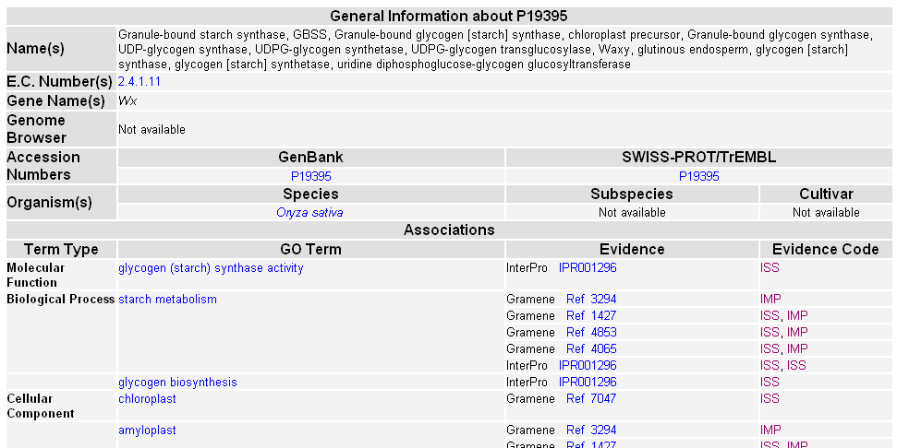

Answer: The term directly related is glycogen biosynthesis. Its molecular function is glycogen (starch) synthase activity. Its role in the biological processes is starch metabolism and glycogen biosynthesis. It’s located in the chloroplast and amyloplast.

Plant Ontology

2a. Go to the Ontology search section on the Gramene Ontology page. Type, “plant anatomy” and search by selecting Plant Ontology (click on the check box). In plant anatomy ontology, click on the term whole plant (GRO:0005000) and report how many major classes of plant parts are listed. Hint: the symbol [i] stands for Instance of and [p] stands for Part of.

1) Enter “plant anatomy” in the Ontology Search field and select Plant Ontology, as shown below.

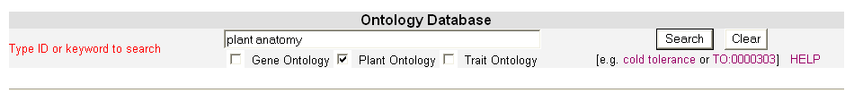
2) The following Summary will result. Select “whole plant,” as shown below.

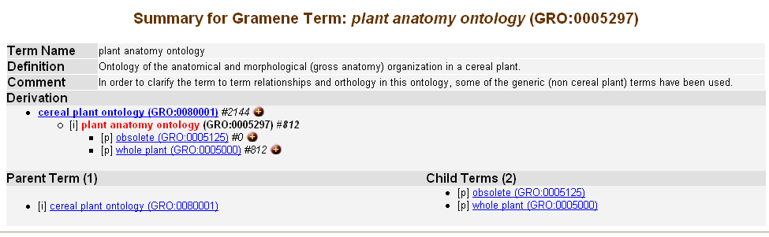

3) The following summary will result. Those terms with a [p] indicate a “Part of.”

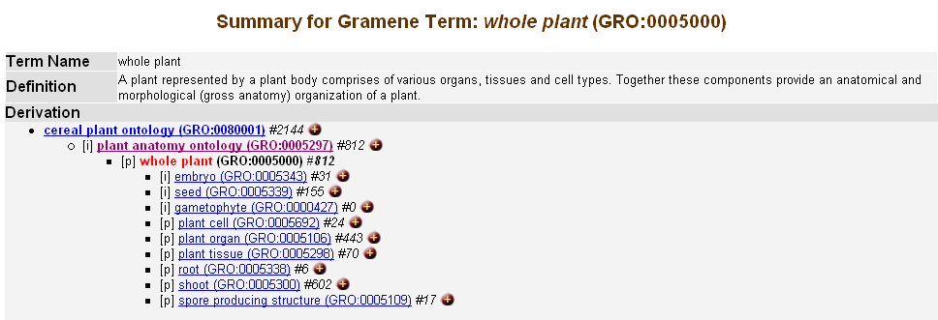

Answer: The major plant parts are plant cell, plant organ, plant tissue, root, shoot, and spore producing structure.

2b. Is seed (GRO:0005339) a Part of [p] or an Instance of [i] whole plant (GRO:0005000)?

Examining the same Summary Page, check to see if there is a [p] or [i] in front of the term “seed.”

Answer: Seed is an instance of a whole plant.

2c. Click on the term seed (GRO:0005339) and report the names and id’s of its two immediate parents. Hint: In a simple hierarchy, seed was always a part of fruit, but Ontology can represent its multiple lineages.

Select “seed,” as shown above. The following Summary will result.

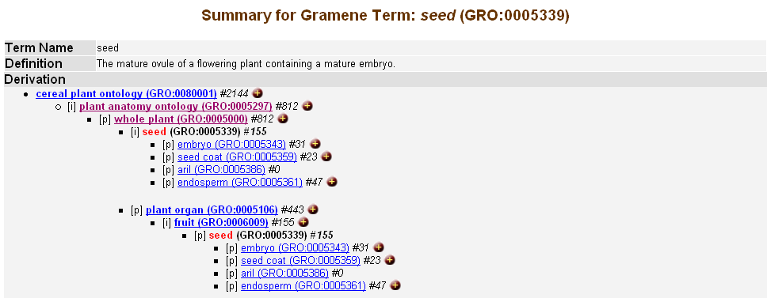

Answer: The two immediate parents are whole plant (GRO:0005000) and fruit (GRO:0006009).

2d. On the same page, report how many phenotypes are associated with the term “seed” (GRO:0005339). Hint: Examine the number following the term id.

In the same Summary, examine the number next to “seed.”

Answer: 155 phenotype genes are associated with the term “seed.”

2e. With the answer from 2d, report how many phenotype genes in total are associated to the children terms of seed (GRO:0005339). Also explain why this number is not the same as you see next to the term seed (GRO:0005339). Hint: There are two types of associations in the ontology: direct associations, which are directly associated to the term for which a phenotype has been characterized and indirect associations, which a term gets from its children terms by virtue of a parent-child relationship. This means anything associated to the child is also associated to its parent and to its grandparent.

In the same Summary, add the numbers located next to “seed’s” children.

Answer: A total of 101 phenotype genes are associated with the children terms of seed. This is not the same number as shown next to the term “seed” because there are certain genes that are directly associated to the term “seed” and are not associated to its children terms.

2f. On the same page, go to the phenotype association section and click on the indirectly associated gene agravitropism-1 and report:
  - What does the description say about this gene?
  - Name the germplasm where it was identified.
  - What are the associated traits?
  - At what growth stages were the traits assayed?
  - In what plant parts (anatomy) were the traits assayed?

1) On the same Summary Page, scroll to the bottom and select “Display All,” as shown below.

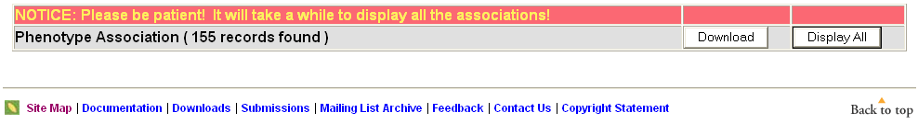

2) Select the term “agravitropism,” as shown below.

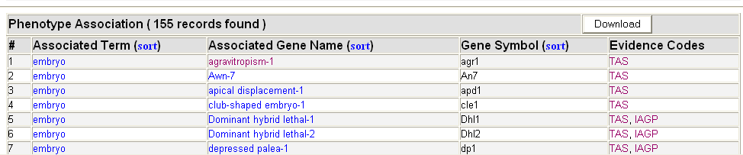

3) The following Mutant Summary page will result. Examine the individual rows and columns for the requested information.

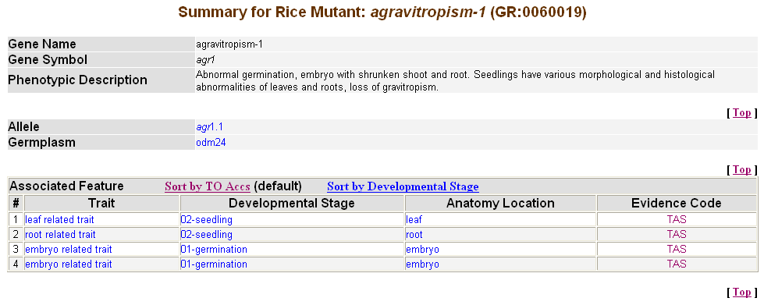

Answer: a) Abnormal germination, embryo with shrunken shoot and root. Seedlings have various morphological and histological abnormalities of leaves and roots, loss of gravitropism.
b) Odm24
c) leaf related trait , root related trait, embryo related trait
d) 02-seedling, 01-germination
e) leaf, root, embryo

3a. Return to the Ontology Search page. Enter the term plant growth stage (GRO:0007199) and report how many organisms the growth stages are listed for.

1) Enter “plant growth stage” in the search field, as shown below.

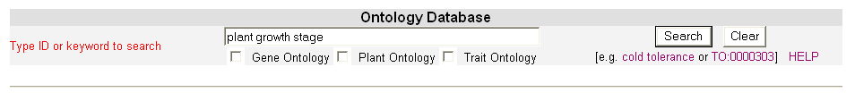

2) The following Summary will result.

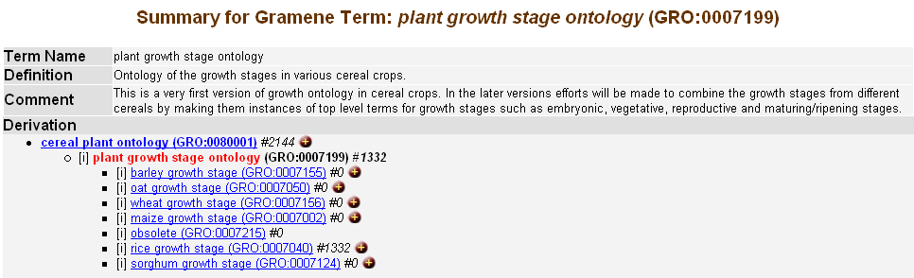

Answer: From six organisms: Barley, Oat, Wheat, Maize, Rice, and Sorghum.
3b. Follow the links on rice growth stages and report the definition and id of the “08 dough stage” in rice.

1) Select “rice growth stage” from the Summary page shown above. Select “Display All” at the bottom of the page. Scroll down the list to “08 dough stage” and select the term, as shown below.

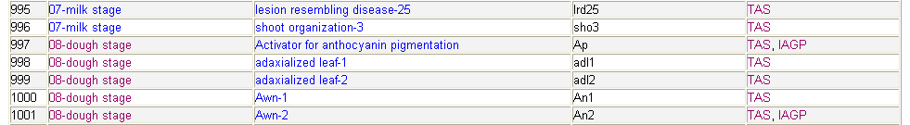

2) The following Summary will result.

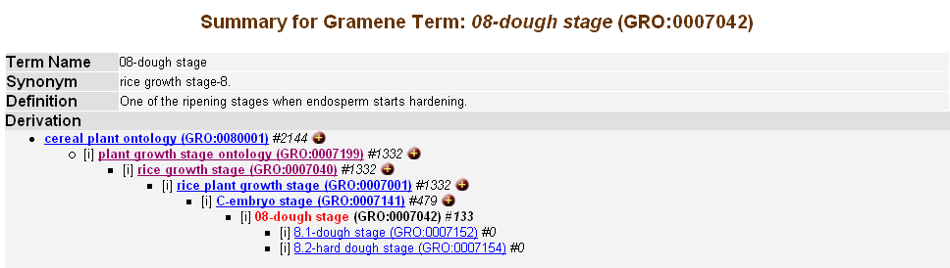

Answer: The definition is “One of the ripening stages when endosperm starts hardening.” The id is GRO:0007042

3c. How many “brittle culm” genes are associated with “dough stage” in rice?

Select “Display All” at the bottom of the above Summary page. The following list will result.

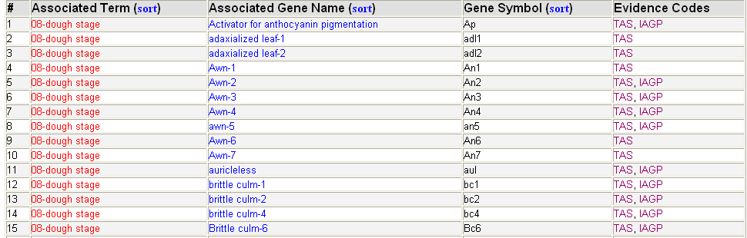

Answer: There are four brittle culm genes associated with growth stage “dough stage.” They are brittle culm-1, brittle culm-2, brittle culm-4, and brittle culm-6.
4. Return to the Ontology Search page. Search for “seedling growth” by selecting “Plant Ontology” and report the unique aspect that is represented. Hint: The same growth stage was identified in how many organisms?

Enter “seedling growth” and select the “Plant Ontology” check box in the main Ontology search field. The following Summary will result.

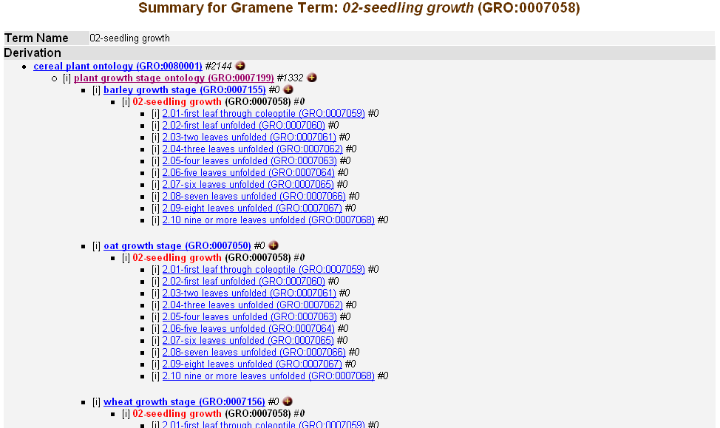

Answer: The term 02-seedling growth (GRO:0007058) is recorded in the same way for barley, oat and wheat.

Trait Ontology

5a. Go to the Ontology search section on the Gramene Ontology page and search for “trait ontology.” How many major categories (except obsolete) of traits are there and which one has the greatest number of associations?

1) On the Ontology search page, enter “trait ontology,” as shown below.

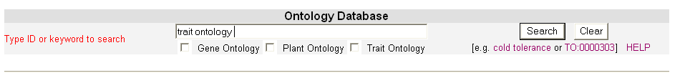

2) The following Summary will result.

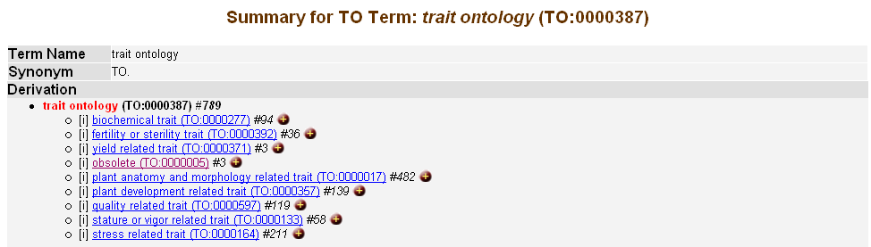
Answer: There are eight major categories of traits. They are biochemical trait (TO:0000277) , fertility or sterility trait (TO:0000392), yield related trait (TO:0000371), plant anatomy and morphology related trait (TO:0000017), plant development related trait (TO:0000357), quality related trait (TO:0000597), stature or vigor related trait (TO:0000133), and stress related trait (TO:0000164).

5b. How many phenotype genes are associated with the trait endosperm color?

In the same Summary Page, select “Display All” at the bottom of the page. The following list will result.

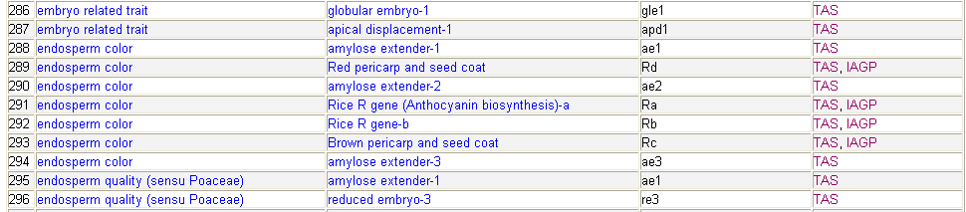

Answer: There are seven phenotype genes associated with the trait term endosperm color (TO:0000487).
5c. What linkage group is the gene Rice R gene (Anthocyanin biosynthesis)-a located on?

1) In the same summary page, select Rice R gene, as shown below.

2) The following Mutant Summary will result.

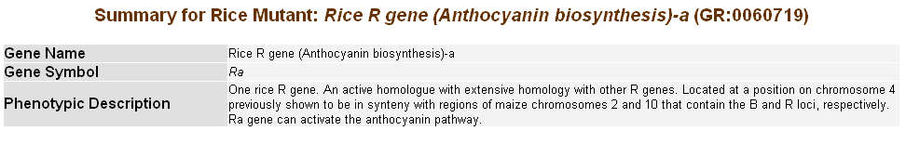
Answer: The gene Rice R gene (Anthocyanin biosynthesis)-a is located on linkage group 4 (evidence Rice-Cornell RFLP 2001 ).

6. Return to the Ontology search page. Name the two trait categories to which the trait “amylose to amylopectin ratio” belongs.

Enter the term “amylose to amylopectin ratio” in the main Ontology search field. The following Summary will result.

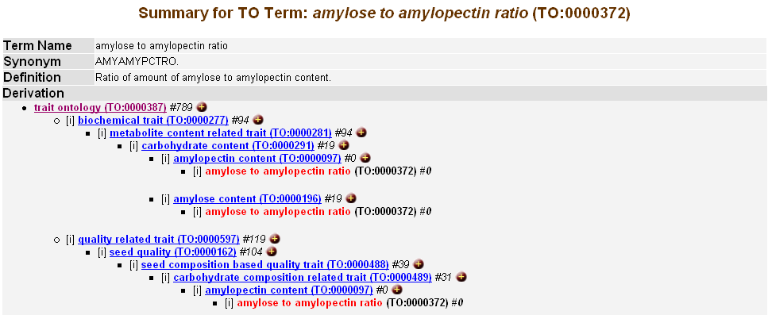

Answer: The trait amylose to amylopectin ratio (TO:0000372) belongs to two categories: biochemical trait (TO:0000277) and quality related trait (TO:0000597).
7a. Return to the Ontology search field. Name the major trait categories of which “stem length” is an instance of.

Enter “stem length” in the main Ontology search field. The following Summary page will result.

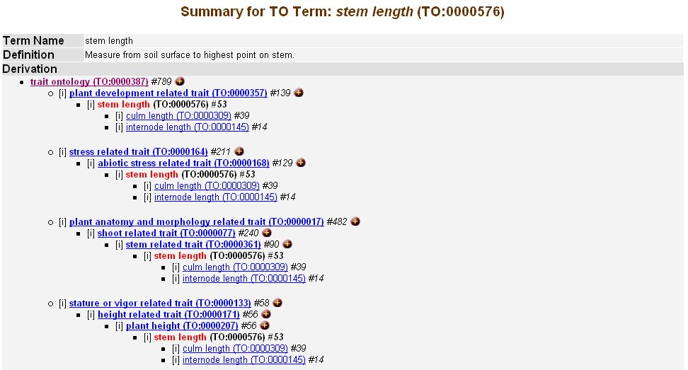

Answer: The trait stem length (TO:0000576) is an instance of four trait categories. The categories are plant development related trait (TO:0000357), stress related trait (TO:0000164), plant anatomy and morphology related trait (TO:0000017), and stature or vigor related trait (TO:0000133).

7b. Name the dwarf genes associated with stem length’s child term “internode length.”

On the same Summary page, scroll down the list of Phenotype Associations.

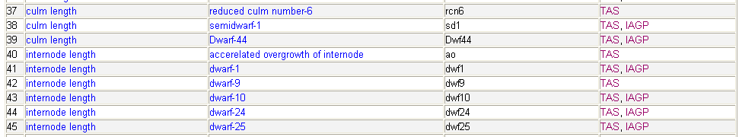

Answer: There are 5 dwarf genes associated with the trait term internode length. They are dwarf-1, dwarf-9, dwarf-10, dwarf-24, dwarf-25.

8a. Return to the Ontology search field. Name the two planthopper resistance traits.

Enter “planthopper resistance” in the main Ontology search field. The following Summary will result.

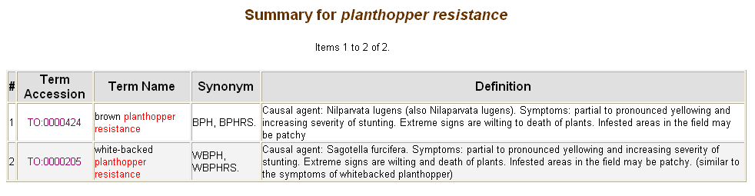

Answer: The two traits are brown planthopper resistance (TO:0000424) and white-backed planthopper resistance (TO:0000205).

8b. Report how many genes are associated with each one of these traits.

Select each of the planthopper resitance term accessions, as shown above. The following summaries will result.

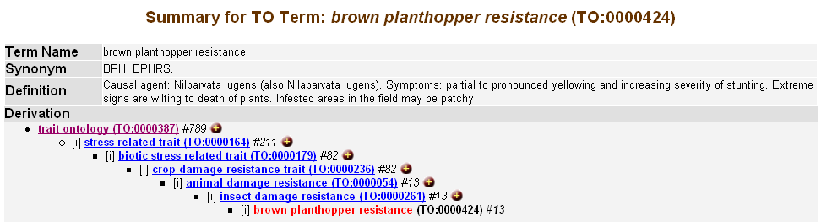

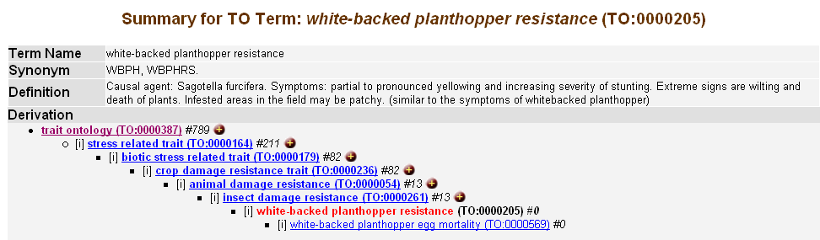

Answer: The trait brown planthopper resistance (TO:0000424) has 13 genes associated with it and the white-backed has 0.

Annotation exercise

Please read the following abstract published on a rice semidwarfing gene and answer the questions that will help in its annotation.

ABSTRACT: ref: DNA Res. 2002 Feb 28;9(1):11-7.

A rice semidwarfing gene, sd-1, known as the "green revolution gene," was isolated by positional cloning and revealed to encode gibberellin 20-oxidase, the key enzyme in the gibberellin biosynthesis pathway. Analysis of 3477 segregants using several PCR-based marker technologies, including cleaved amplified polymorphic sequence, derived-CAPS, and single nucleotide polymorphisms revealed 1 ORF in a 6-kb candidate interval. Normal-type rice cultivars have an identical sequence in this region, consisting of 3 exons (558, 318, and 291 bp) and 2 introns (105 and 1471 bp). Dee-Geo-Woo-Gen-type sd-1 mutants have a 383-bp deletion from the genome (278-bp deletion from the expressed sequence), from the middle of exon 1 to upstream of exon 2, including a 105-bp intron, resulting in a frame-shift that produces a termination codon after the deletion site. The radiation-induced sd-1 mutant Calrose 76 has a 1-bp substitution in exon 2, causing an amino acid substitution (Leu [CTC] to Phe [TTC]). Expression analysis suggests the existence of at least one more locus of gibberellin 20-oxidase which may prevent severe dwarfism from developing in sd-1 mutants.

Use the highlighted terms to answer the following.

9a. What is the name of the rice gene mentioned in the above abstract?

Answer: semidwarfing gene, green revolution gene

9b. What is the gene symbol suggested by the authors?
Answer: sd-1

9c. What is the name of the enzyme (protein) encoded by this gene?

Answer: gibberellin 20-oxidase

9d. Name the rice germplasms from where the mutant gene was isolated.

Answer: Dee-Geo-Woo-Gen and Calrose 76

9e. Using the Gene Ontology search, suggest the following characteristics of this gene by providing the GO terms and their respective id’s.

a. Molecular function
b.Biological process

Answer: a) gibberellin 20-oxidase activity (GO:0045544)
b) gibberellic acid biosynthesis (GO:0009686) and gibberellic acid mediated signaling (GO:0009740)

9f. Find the Trait Ontology terms and their ids representing the traits observed in the phenotype.

Answer: plant height (TO:0000207) and gibberellic acid sensitivity (TO:0000166)

